1. Show all of the information on the Avengers.

a. Query: SELECT \* FROM avengers

b. Columns: 21

c. Expected row count: 171

d. Screenshot

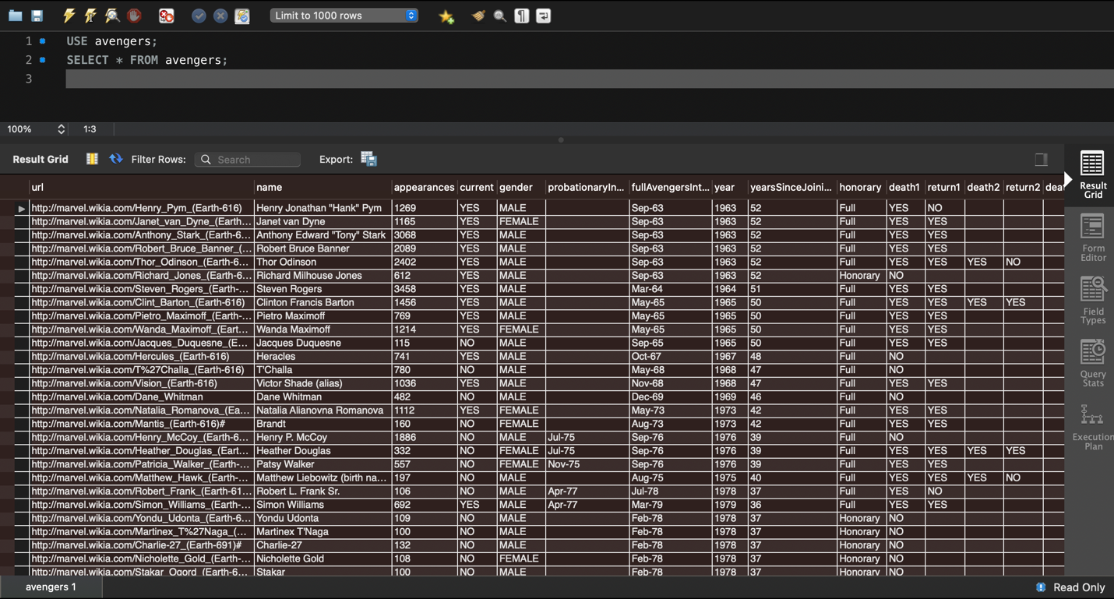

1. Create a new table with information from another super hero group [can be imported from elsewhere or fictitious]. Make sure there is an appropriate header and must be at least 30 rows.
   1. Query: SELECT \* FROM HerosRUS;

INSERT INTO HerosRUS (name,intelligence,strength,speed,durability,combat,power)VALUES

-- ('Allen Walker',56,65,75,20,50,66),

-- ('Air Walker',33,22,96,44,33,81),

-- ('Sky Walker',77,88,50,86,100,95),

-- ('Water Walker',77,88,50,86,100,95),

-- ('Dust Walker',77,88,50,86,100,95),

-- ('Bread Walker',77,88,50,86,100,95),

-- ('Bond Walker',77,88,50,86,100,95),

-- ('Walter Walker',77,88,50,86,100,95),

-- ('Danny Walker',56,65,75,20,50,66),

-- ('Paul Walker',33,22,96,44,33,81),

-- ('Roger Walker',77,88,50,86,100,95),

-- ('Andy Walker',77,88,50,86,100,95),

-- ('Crazy Walker',77,88,50,86,100,95),

-- ('Solo Walker',77,88,50,86,100,95),

-- ('Woki Walker',77,88,50,86,100,95),

-- ('Mac Walker',77,88,50,86,100,95),

-- ('Every Walker',56,65,75,20,50,66),

-- ('Pod Walker',33,22,96,44,33,81),

-- ('ATAT Walker',77,88,50,86,100,95),

-- ('Darth Walker',77,88,50,86,100,95),

-- ('Red Walker',77,88,50,86,100,95),

-- ('Green Walker',77,88,50,86,100,95),

-- ('Blue Walker',77,88,50,86,100,95),

-- ('Oil Walker',77,88,50,86,100,95),

-- ('Oreo Walker',56,65,75,20,50,66),

-- ('F1 Walker',33,22,96,44,33,81),

-- ('Ice Walker',77,88,50,86,100,95),

-- ('Choco Walker',77,88,50,86,100,95),

-- ('Icecream Walker',77,88,50,86,100,95),

-- ('Bagel Walker',77,88,50,86,100,95),

-- ('James Walker',77,88,50,86,100,95),

-- ('Dune Walker',77,88,50,86,100,95);

* 1. Columns 8
  2. Expected row count 32
  3. Screenshot Table

     Description automatically generated

1. Add a column to your new table (let us call it the new superheros) for those who are interested in joining the Avengers. Make this be randomly assigned. Hint: it is okay for this to be a multi-step query. You will have to use rand() function and CASE WHEN statement too.
   1. Query: ALTER TABLE HerosRUS ADD COLUMN interested INT; UPDATE HerosRUS SET Interested = (CASE WHEN rand() >0.5 THEN 1 ELSE 0 END);
   2. Columns 9
   3. Expected row count 32
   4. Screenshot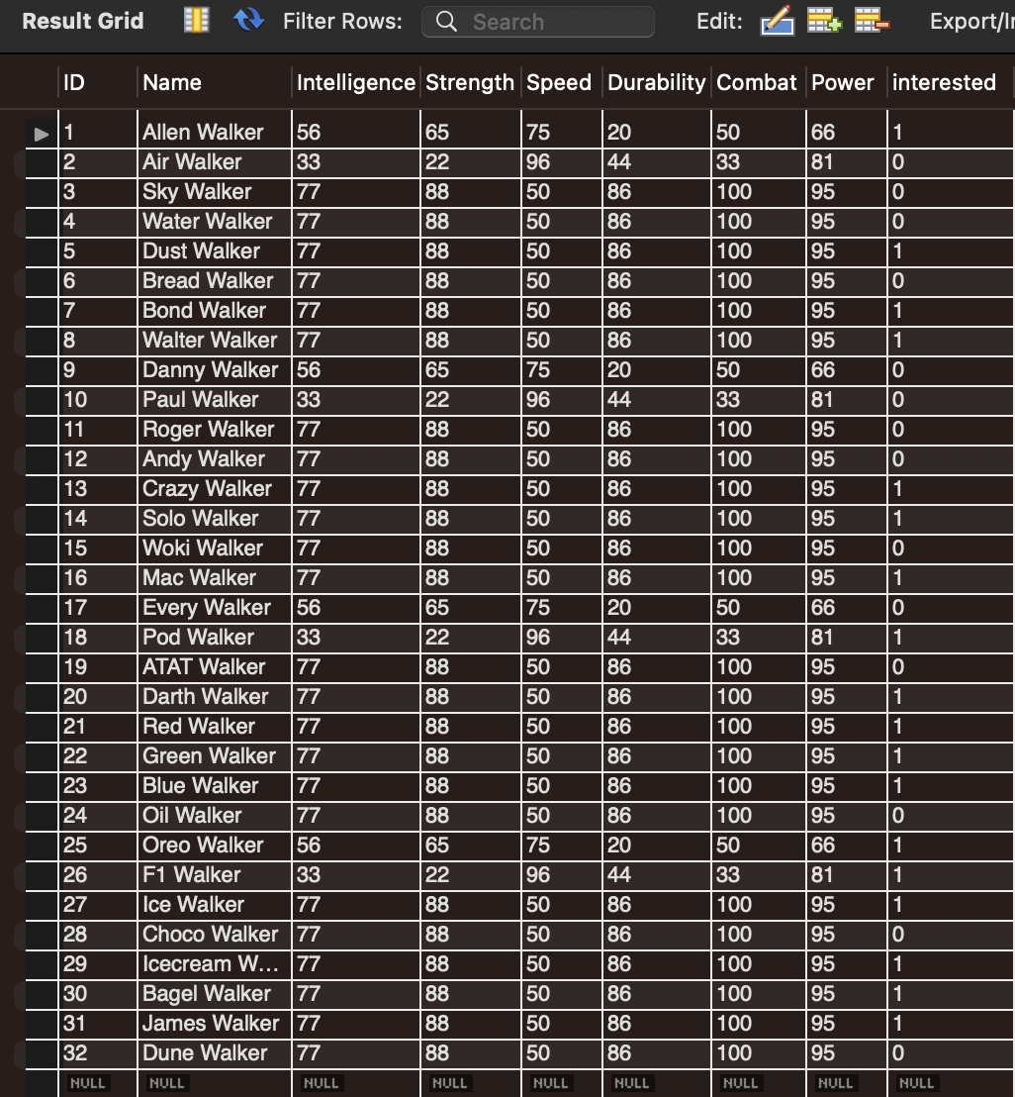
2. Add a column to your new table (the new superheros) for their favorite Avenger (have it randomly choose between Anthony Edward "Tony" Stark, Robert Bruce Banner, & Victor Shade).
   1. Query: ALTER TABLE HerosRUS ADD COLUMN favourite VARCHAR(42); UPDATE HerosRUS SET favourite = (CASE WHEN rand() <0.3 THEN 'Anthony Edward "Tony" Stark' WHEN rand() <0.6 THEN 'Victor Shade' ELSE 'Robert Bruce Banner' END);
   2. Columns 10
   3. Expected row count 32
   4. Screenshot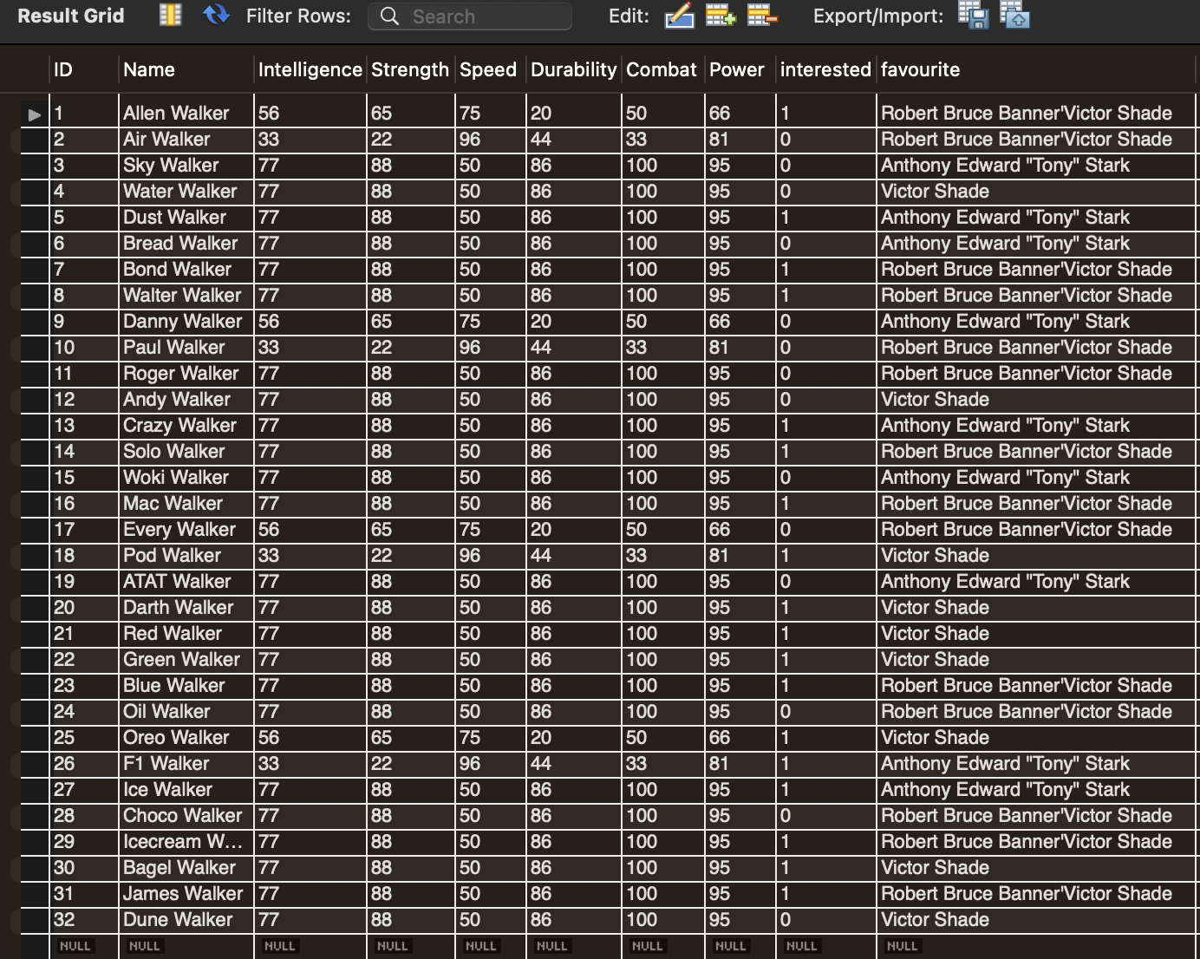
3. Use a JOIN statement between the two tables for who is interested in joining the Avengers.
   1. Query:
   2. Columns
   3. Expected row count
   4. Screenshot
4. List all Avengers who have more than 1000 appearances in alphabetic order.
   1. Query:
   2. Columns
   3. Expected row count
   4. Screenshot
5. What Avengers do not have more than 1000 appearances?
   1. Query:
   2. Columns
   3. Expected row count
   4. Screenshot
6. Not more than 500?
   1. Query:
   2. Columns
   3. Expected row count
   4. Screenshot
7. Not more than 50 and female?
   1. Query:
   2. Columns
   3. Expected row count
   4. Screenshot
8. More than 150, male, and are full members?t
   1. Query:
   2. Columns
   3. Expected row count
   4. Screenshot